**Provide Insights to the Marketing Team in Food & Beverage Industry**

Codex SQL Codes

1. **Who prefers energy drink more?**

select Gender,count(respondent_id) as prefer_drink_more from

dim_repondents

group by Gender

order by prefer_drink_more desc;

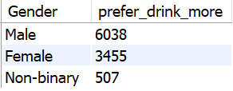

1. **Which age group prefers energy drinks more?**

SELECT age as age_groups ,count(respondent_id) as count

from dim_repondents

group by age_groups ;

1. **Which type of marketing reaches the most Youth (15-30)**

SELECT r.age, s.Marketing_channels,count(r.Respondent_ID) as count

FROM fact_survey_responses s

JOIN dim_respondents r ON R.Respondent_ID = S.Respondent_ID

WHERE R.age BETWEEN 15 AND 30;

GROUP BY S.Marketing_channels

order by count desc;

1. **What are the preferred ingredients of energy drinks among respondents?**

SELECT Ingredients_expected,COUNT(RESPONDENT_ID) AS COUNT_RESPONSES FROM

fact_survey_responses

group by Ingredients_expected

order by COUNT_RESPONSES Desc;

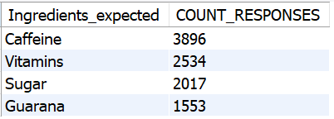

1. **What packaging preferences do respondents have for energy drinks**

SELECT Packaging_preference,COUNT(RESPONDENT_ID)

AS COUNT_RESPONSES

FROM fact_survey_responses

group by Packaging_preference

ORDER BY COUNT_RESPONSES DESC;

1. **Who are the current market leaders?**

SELECT Current_brands,COUNT(RESPONDENT_ID)

AS COUNT_RESPONSES FROM fact_survey_responses

GROUP BY Current_brands

ORDER BY COUNT_RESPONSES DESC;

1. **What are the primary reasons consumers prefer those brands over ours?**

select Reasons_for_choosing_brands,count(Respondent_ID)

as count_responses

from fact_survey_responses

group by Reasons_for_choosing_brands

order by count_responses desc;

1. **Which marketing channel can be used to reach more customers?**

select Marketing_channels,count(Respondent_ID)

as count_no_responses

from fact_survey_responses

group by Marketing_channels

order by count_no_responses desc;

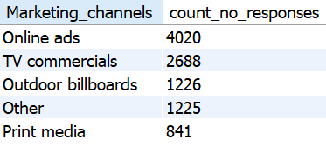

1. **What do people think about our brand?**

select Heard_before,count(respondent_id) as count_responses from

fact_survey_responses

group by Heard_before

order by count_responses desc;

**Respondent heard before tried or not tried**

select Tried_before,count(respondent_id) as count_responses from

fact_survey_responses

where Heard_before="yes"

group by Tried_before

order by count_responses desc;

**Taste experience rating**

select Taste experience as Taste_experience_rating,count(Respondent_id)

as count_of_responses from

fact_survey_responses

where Tried_before="yes" and Heard_before="yes"

group by Taste_experience_rating

order by count_of_responses desc;

1. **Which cities do we need to focus more on?**

select C.City,c.Tier,count(r.respondent_id) as count_responses,

round((count(r.respondent_id)/10000*100),2) as pct_responses

from dim_cities c

join dim_repondents r

on c.City_ID=r.City_ID

group by c.city

order by count_responses desc;

1. **Where do respondents prefer to purchase energy drinks?**

select Purchase_location, count(respondent_id) as no_of_responses

from fact_survey_responses

group by Purchase_location

order by no_of_responses desc;

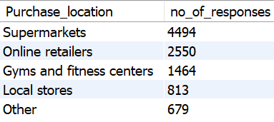

1. **What are the typical consumption situations for energy drinks among respondents?**

select Typical_consumption_situations, count(respondent_id) as no_of_responses

from fact_survey_responses

group by Typical_consumption_situations

order by no_of_responses desc;

1. **What factors influence respondents' purchase decisions, such as price range and limited edition packaging?**

select Limited_edition_packaging, count(respondent_id) as no_of_responses

from fact_survey_responses

group by Limited_edition_packaging

order by no_of_responses desc;

**Price Range**

select Price_range, count(respondent_id) as no_of_responses

from fact_survey_responses

group by Price_range

order by no_of_responses desc;

1. **Which area of business should we focus more on our product development?**

select Reasons_for_choosing_brands, count(respondent_id) as no_of_responses

from fact_survey_responses

where current_brands= ”codex”

group by Reasons_for_choosing_brands

order by no_of_responses desc;

